Software Quality Assurance (SQA) – 2ST Week Project Task
Name: Dariya Hashmi -- DHC (2403)
Project Title: COMPATIBILITY AND RETESTING REPORT

1. CROSS-BROWSER COMPATIBILITY REPORT

Step 1: Understand the Purpose
- Goal: Ensure your website looks and works correctly on different browsers.
- Browsers can interpret HTML, CSS, and JavaScript differently.
- Common browsers to test:
- Google Chrome
- Mozilla Firefox
- Microsoft Edge

Step 2: Identify Features to Test
Decide what parts of the website you will check. Usually, core features like:
- Homepage layout
- Login functionality
- Product search
- Add to cart
- Checkout
- Logout

Step 3: Testing Procedure
- Open your website in Chrome, Firefox, and Edge.
- Go feature by feature and check if:
- Layout is correct
- Buttons work
- Images load
- Forms function
- Note Pass if it works, Fail if not.

Step 4: Document Results

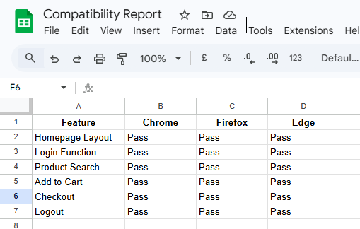

Step 5: Result Summary
Example:
The website works properly on all tested browsers. No major compatibility issues were found. Minor CSS adjustments may be needed for smaller screen devices.

2. RETESTING REPORT

Step 1: Understand Retesting
- Goal: Check if previously reported bugs have been fixed.
- Only test bugs that were open or unresolved before.

Step 2: List Bugs
- Use the bug list from your bug tracking tool or previous reports.
- Include:
- Bug ID
- Bug Title
- Previous Status

Step 3: Retesting Procedure
- Test each bug again in the same environment where it was reported.
- Record Retest Result:
- Fixed → Problem resolved
- Not Fixed → Problem still exists
- Update Final Status:
- Closed → Bug resolved
- Still Open → Bug unresolved

Step 4: Document Results

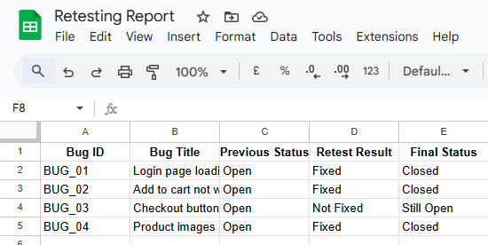

Step 5: Summary
Example:
Bugs BUG_01, BUG_02, and BUG_04 were fixed successfully. BUG_03 still needs attention as the checkout button is not responding.

Github repoistry link:

https://github.com/dariyahashmi2602-source/Website_Testing_Reports

